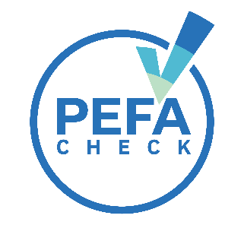
Instructions for the preparation and use of a PEFA assessment quality statement
The statement template below will provide crucial information about quality assurance arrangements for a PEFA assessment:

PEFA assessment quality statement

This statement describes the quality assurance arrangements for the PEFA assessment of:
[Insert the name of the country, or the subnational entity and country]
Funded by: [Insert the name of the agency (agencies) commissioning the assessment, or the government]
Led by: [Insert the name of the leading agency, or the government, or both]
The assessment manager of the PEFA assessment is [insert the name, position and institution].
The assessment manager will ensure that:
- a draft concept note is prepared and reviewed by 4 independent peer reviewers including the PEFA secretariat
- the concept note will be finalized before on-site data collection commences
- the complete draft PEFA report is submitted to all peer reviewers for review
- a revised draft PEFA report is prepared by the assessment team attaching a matrix with peer reviewers’ comments and assessment team responses
- the final report is reviewed by the PEFA secretariat to ensure that all three quality index thresholds are met
- the final report will include details of the quality assurance procedures as specified in PEFA secretariat guidance
- PEFA Check endorsement will be requested from the PEFA secretariat if requirements have been met following PEFA secretariat guidance
- the final report is submitted to government, as the owner of the report, for dissemination and action
The PEFA Secretariat will assign a staff member to provide technical advice to the assessment manager, or their delegate, throughout the PEFA assessment.
Statement date: [insert the date]

